EXPERIMENT 1
Ex. No.: 1
Estimation of Characteristic Impedance (Z0) and Propagation Constant (γ) of a Transmission Line from Primary Constants
AIM: To estimate the characteristic impedance (Z0) and propagation constant (γ) of a transmission line from its primary constants R, L, G and C using Scilab.
SOFTWARE REQUIRED: Scilab 6.1.1
PROGRAM
clear; clc;
R=10; L=3.5e-3; G=4e-6; C=8e-6; f=2000;
w=2*%pi*f;
Z=R+%i*w*L; Y=G+%i*w*C;
Z0=sqrt(Z/Y); gamma=sqrt(Z*Y);
printf("Z0 = %.4f + j(%.4f) ohms\n",real(Z0),imag(Z0));
printf("Alpha = %.6f neper/km\n",real(gamma)*1000);
printf("Beta = %.6f radians/km\n",imag(gamma)*1000);
TEST CASES AND OUTPUT
Test Case 1: R=10 Ω/km, L=3.5 mH/km, G=4 μS/km, C=8 μF/km, f=2 kHz
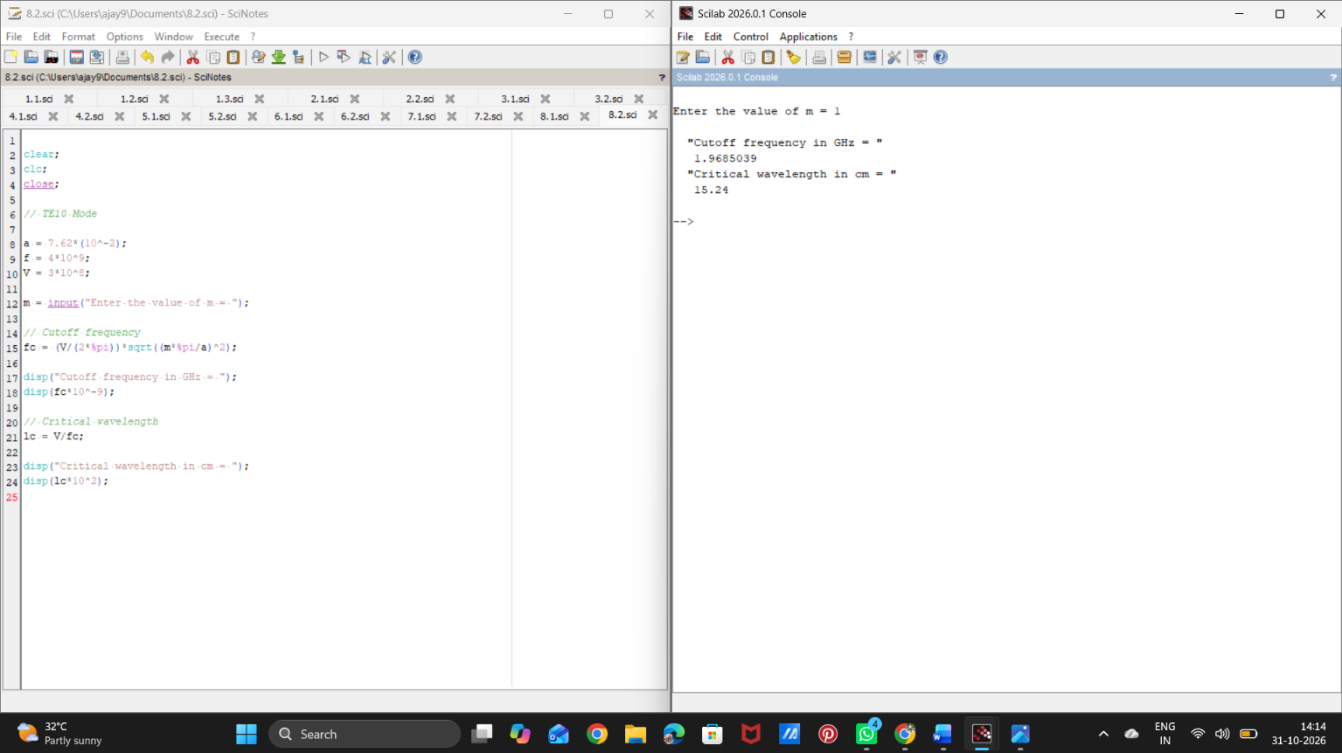

Test Case 2: R=20 Ω/km, L=5 mH/km, G=5 μS/km, C=10 μF/km, f=2.5 kHz
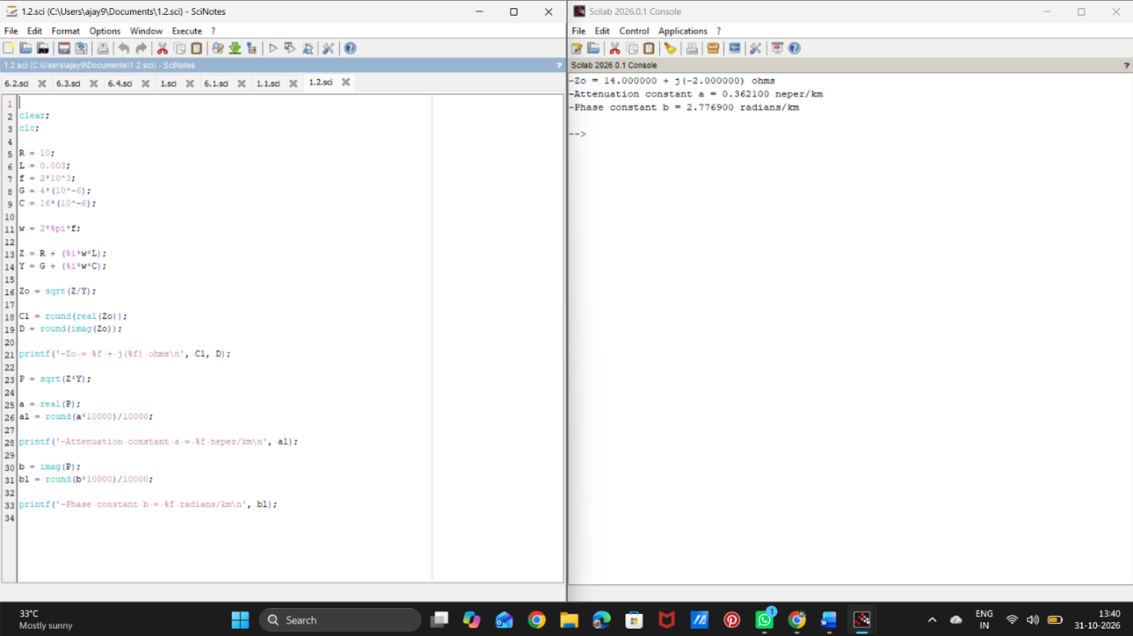
Test Case 3: R=30 Ω/km, L=7.5 mH/km, G=6 μS/km, C=12 μF/km, f=3 kHz
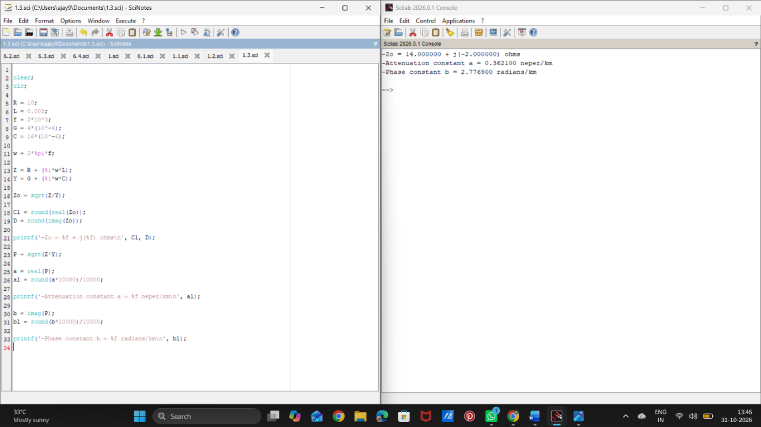
RESULT
Thus, the characteristic impedance and propagation constant of the transmission line were estimated from its primary constants using Scilab.

